


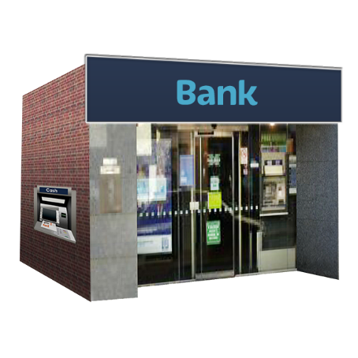
Banking Ombudsman Scheme –
Making a complaint about
your bank

Published: June 2026

What you will find in here

Page number:
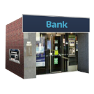

About this Easy Read 2


The Banking Ombudsman
Scheme 4


How to make a complaint 6


Early resolution service 11

Dispute resolution service 16


Making a decision 18

About this Easy Read


This Easy Read is from the Banking Ombudsman Scheme.
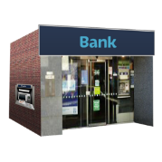

The Banking Ombudsman Scheme can support you to sort out problems you have with your bank.


There is more information about the Banking Ombudsman Scheme on pages 4 to 5 of this Easy Read.


In this Easy Read we / us / our means the Banking Ombudsman Scheme.

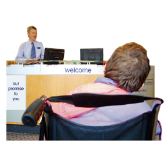
This Easy Read has information about how to make a complaint if there is a problem with your bank.


Making a complaint means telling someone:
there is a problem
you want them to do something to fix the problem.

The Banking Ombudsman Scheme

The Banking Ombudsman Scheme is a dispute resolution service.


A dispute resolution service works to find a way to sort out disputes.


Here a dispute is if you do not agree with something your bank has:
decided
done.


The Banking Ombudsman Scheme is:
free / does not cost money
independent.
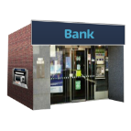

Here independent means the banks cannot tell the Banking Ombudsman Scheme what to do.


We can look into most complaints about banking.


Most of the time we support people to sort things out with their bank.


If a complaint cannot be sorted out we can decide what will happen.


We can also give you information about banking.


We cannot tell you:
what to do
how to manage your money.

How to make a complaint


You can contact us if you want to make a complaint.


You can also contact us if you are not sure if you want to make a complaint.


When you contact us we will:
listen
support you to decide what to do next.


You can email us at:

help@bankomb.org.nz


You can phone us from Aotearoa New Zealand on:

0800 805 950


It does not cost money to phone this number.


If you find it hard to use the phone the New Zealand Relay service is for people who are:

- Deaf / hard of hearing

- deafblind

- speech impaired / find it hard to talk.

You can find out more about the
New Zealand Relay service at:

www.nzrelay.co.nz


If you are overseas you can phone us on:

+64 4 915 0400


It will cost money to phone us from overseas.

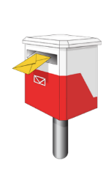
You can post a letter to us at:

Freepost 218002

PO Box 25327

Wellington 6140


You do not need a stamp to post a letter to us.


You can make a complaint by filling out the online complaint form on our website at:


https://tinyurl.com/bos-complaintform

The online complaint form is not in Easy Read.

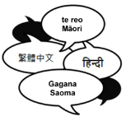
There is information on our website if you:

speak a language that is not English
need to use the New Zealand Relay Service.


You can find this information on our website at:

https://tinyurl.com/bos-specialassistance

Early resolution service

The early resolution service can support you to work with your bank
to fix your problem.
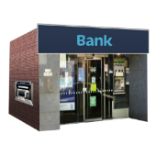

You may already have made a complaint to your bank.

If so we can consider your complaint straight away.

Here consider means:

look into something
and
make a decision about it.


Most people who contact the early resolution service get their complaint sorted out.

After we get your complaint we will send it to your bank.


Your bank must have a fair chance to:
look into what happened
fix your problem.


Your bank will contact you to say what they have decided about your complaint.


You can contact us if you:
need support to understand what your bank has said
still have a problem with your bank.


We can give advice to:
you
your bank.


You can contact us for advice if your bank has made an offer to sort out your complaint.


Here an offer is where your bank says what they will do to fix your problem.


You can choose if you want to
accept / say yes to the offer from your bank.


If you accept / say yes to the offer it will become a full and final settlement.

A full and final settlement means:

everyone has agreed about what is to happen
no one can change their mind.


We cannot look into your complaint after there has been a full and final settlement.


You can find more information about making a complaint to your bank on our website at:


https://tinyurl.com/bos-moreinfo

There is information about how complaints from other people have worked out on our website at:

https://tinyurl.com/bos-casenotes

You can find information about a lot of things to do with banking on our website at:
https://tinyurl.com/bos-quickguides

Our website is not in Easy Read.

Dispute resolution service


You can use our disputes resolution service if:
you are not happy with the offer from your bank


your bank has not made an offer 2 months after getting your complaint.


We will look at your complaint to see if it is something we can consider.


You can find information about the kinds of complaints we can / cannot consider on our website at:

https://tinyurl.com/bos-canconsider

Our website is not in Easy Read.


If we can consider your complaint we will ask for information from:
you
your bank.


We will try to support both sides to come to an agreement.


We may say what we think would be a fair way to sort things out.

Making a decision


We can make a decision if you cannot come to an agreement with your bank.


First we will make a preliminary decision.


A preliminary decision is when we say what decision we will probably make.


You can respond to our preliminary decision.


Here respond means:
tell us if you agree with our decision
give us new information about your complaint.

Your bank can respond to our preliminary decision too.


If we find your bank did something wrong we will recommend ways to put things right.


Here recommend means say what we think is the best thing to do.


Some ways your bank could fix your problem are by:
apologising / saying sorry

changing a decision
paying you some money.


You can find out more about how banks can fix problems on our website at:
https://tinyurl.com/bos-compensation

Our website is not in Easy Read.


If everyone agrees with our decision it becomes final.


You cannot appeal a final decision.

When you appeal something it means you ask someone to:
take another look at a decision
think about changing the decision.

If you accept / say yes to our decision it is binding on your bank.


Here binding means the bank must do what we have said.


If you do not accept / say yes to our decision you can look at other ways to sort out your complaint like going to court.


This information has been written by the Banking Ombudsman Scheme.


It has been translated into Easy Read by the Make it Easy Kia Māmā Mai service of People First New Zealand Ngā Tāngata Tuatahi.

The ideas in this document are not the ideas of People First New Zealand Ngā Tāngata Tuatahi.

All images used in this Easy Read document are subject to copyright rules and cannot be used without permission.


Make it Easy uses images from:


- Photosymbols

- Change Images


- Huriana Kopeke-Te Aho

- SGC Image Works

- T Wood


- Studio Rebeko

- Inga Kramer.

